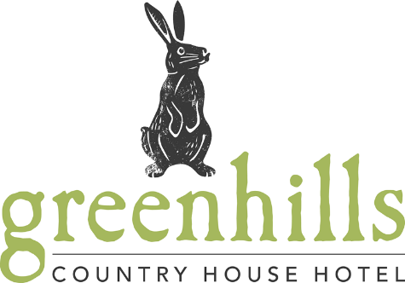

Service times

Breakfast served from
8am till 11am

Continental Breakfast
£8.50

Juices
Orange, Cranberry, Grapefruit, Apple

Chilled water also provided

Yoghurt
Jersey Dairy yoghurt pots – varies flavours
Natural yoghurt

Fruit Basket
Selection of fresh fruit
(Apple, Banana, Mandarin, Pears, Seasonal Fruits)

Pastries
Freshly baked pastries
Croissant, Pain Au Chocolat,
French Apricot, Pastry Whirl

Vegan
Chia seed pudding

From The Kitchen
Everything is cooked fresh to order so please note that during busy times food may take that little bit extra time to prepare. Give our chefs time to work their magic and start your day right!

Oatmeal £5.50
Served with banana & almond, apple & cinnamon or carrot cake
(gluten free & vegan option available)

The Greenhills Country Breakfast £14.50
Free-range eggs - scrambled, poached or fried, locally produced pork sausage and bacon, button mushrooms, grilled tomato, black pudding, baked beans and hash brown.
Tea and coffee included.

The Greenhills Country House
Vegan/Vegetarian Breakfast £14.50
Falafel, avocado, rocket salad, cherry tomato
Tea and coffee included.

Greenhills American Style Pancakes
With bacon & maple syrup £9.50
OR seasonal fruits & maple syrup £10.50

Greenhills Country House Egg Specials
Eggs Benedict – poached egg, Parma ham, rocket salad, pine nuts £8.50
Two Egg Omelette – choose your filling;
ham, cheese, tomato, spinach, smoked salmon, bacon or mushroom £8.50
Eggs Royale – smoked salmon, poached egg, hollandaise sauce £10.50

Smoked Haddock £12.50
Served with either free range poached egg or scrambled egg

Greenhills Country breakfast & vegan/vegetarian breakfast are served with freshly made toast – white, brown, wheat-meal and gluten free available

